KM plot in Tableau

Prerequisite:

* Tableau Desktop installed
* Tableau Prep builder installed

Note: Tableau for student can get 1 year free account, download from <https://www.tableau.com/academic/students>, below demonstration is based on version Tableau Desktop 2022.3 and Tableau Prep Builder 2022.4 on Mac



* Benchmark data and Synthea data in CSV form prepared (detail in file – generate Synthea data)

Difference between Tableau Prep and Tableau Desktop

Tableau Prep can do more complex data clean and data process steps to show the flow and the Tableau Desktop can connect to the result from Tableau Prep to do interactive visualization

Below is the demonstration for two drugs example in tableau

1. Create a Flow in Tableau Prep and Connect to the data

Open Tableau Prep and press the right button next to the Connections -> To a File -> Text file and select the needed csv files in the located path

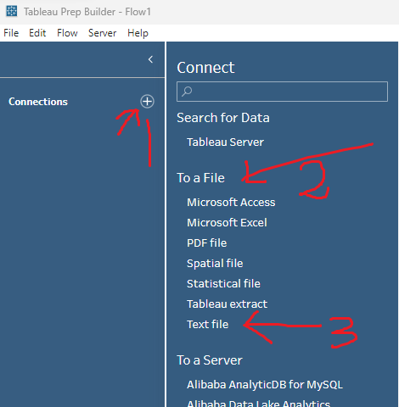

then get the window shown below.

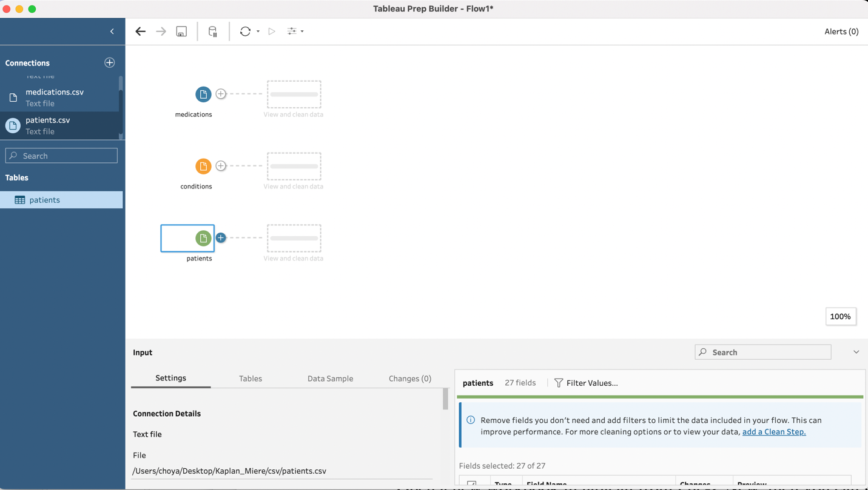

Note, before we connect to the CSV file, we need to do some extra modifications to the csv. file, we need to insert a few blank rows into each file.

* For patients.csv, we add an extra row between the column name and the first record(shown below marked with red). Set the ID as ‘Added’ and leave other columns blank. 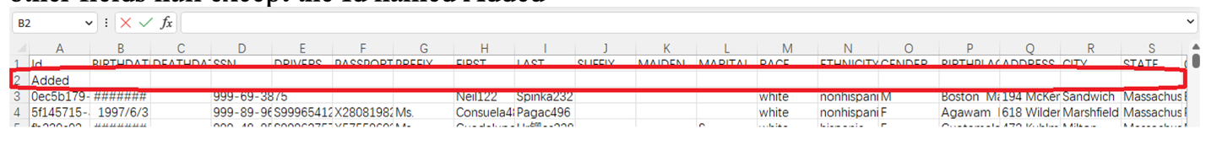
* For condition.csv, we add an extra row Set the ID as ‘Added’ , DESCRIPTION as ‘Malignant neoplasm of breast (disorder)’ and leave other columns blank.



* For medication.csv, we also add two extra rows. For first row set the ID as ‘Added’, DESCRIPTION as ‘Malignant neoplasm of breast (disorder)’ REASONDESCRIPTION as’100 ML Epirubicin Hydrochloride 2 MG/ML Injection’ and leave other columns blank, while second row set the ID as ‘Added’, DESCRIPTION as ‘Malignant neoplasm of breast (disorder)’ REASONDESCRIPTION Paclitaxel 100 MG Injection’ and leave other columns blank.



These steps are for the origin points in the Kaplan-Meier curve (Time at 0 the survival probability is 1)

Now we can go back to tableau Prep and choose the modified CSV files.

1. Add the process step into the Flow
   1. Remove duplicate rows by aggregate

Click ‘+’ add button(shown as image below) near the data -> Aggregate -> choose Add All under Settings.

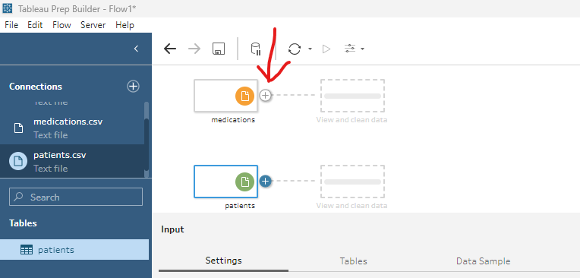

* 1. Rename column filed

As there are same column name across the table, we add suffix about the source table of the column.

Click ‘+’ add button -> Clean Steps :Rename Fields -> select Add suffix in the For each field in check box

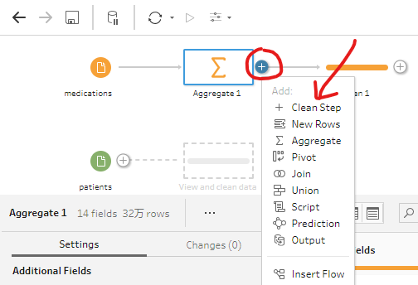 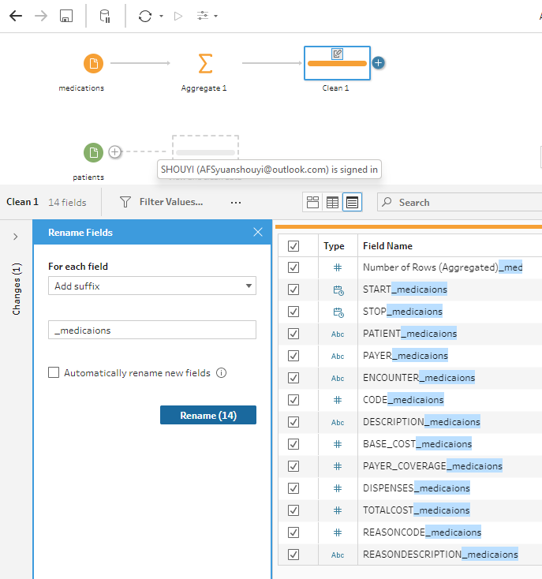

We do the step both for condition and medication and add suffix ‘_condition’ to column in the condition.csv and ‘_medication’ to column in the medication’.csv.

* 1. Join files

Click ‘+’ add button -> Join ->

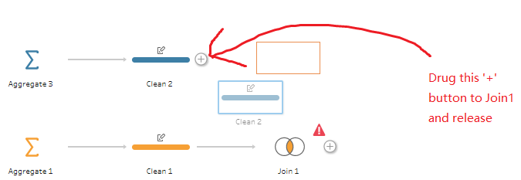

select the columns that join condition on Condition.csv, patient.csv and medication.csv join with below condition in the applied join

* + - Condition.csv inner join with Patients.csv

on Patient(Condition.csv) == Id(from Patients.csv)

* + - Condition.csv inner join with Medication.csv on

on Patient(Condition.csv) = Patient (Medication.csv)

and Description(Condition.csv) == ReasonDescription(Medication.csv)

* 1. Add calculated fields

Click ‘+’ add button -> Clean Steps :Create Calculated Field

* + Status

The status of the patient, 1 represents alive while 0 represents death

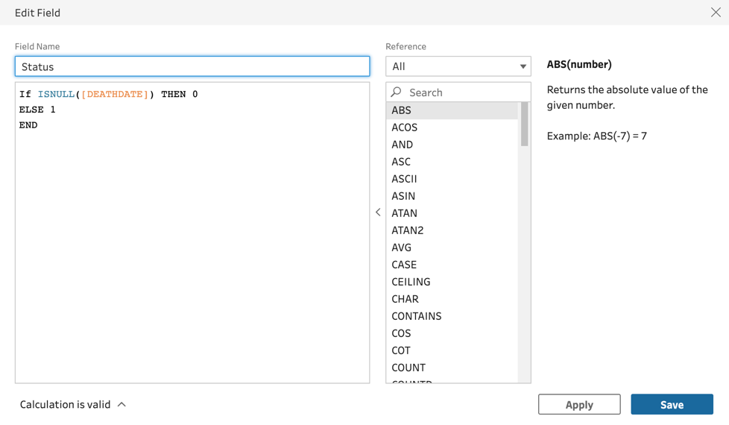

* + survival_analysis_endtime (here we use the date to today as default, but it can be replaced with the date when data was extracted)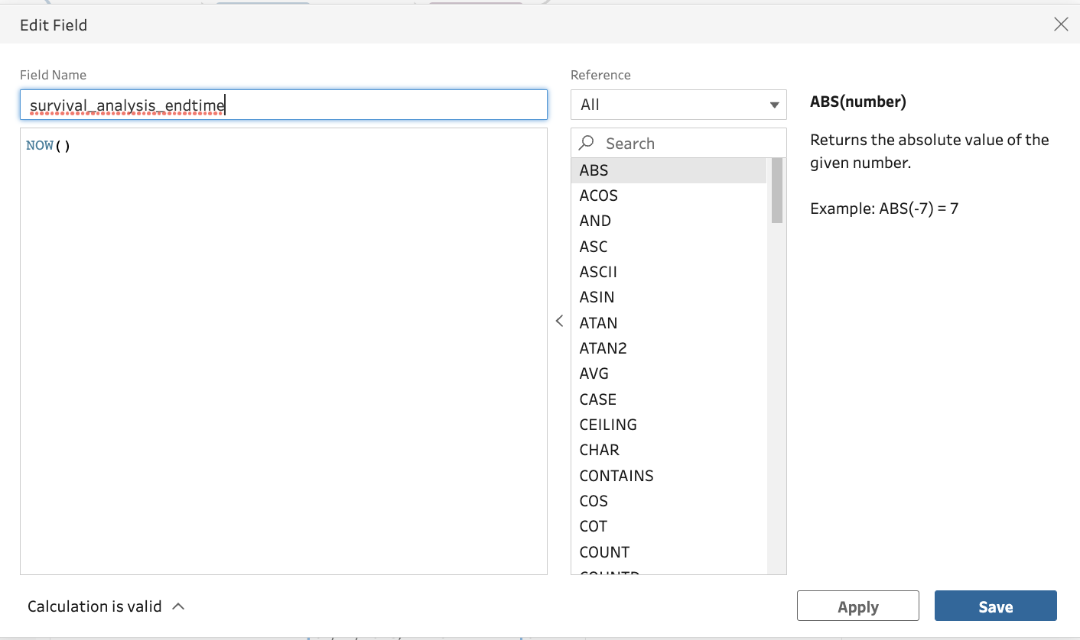
  + earliest_medication_starttime

The earliest time for a patient to take the medication which considers as the start time in the given survival analysis

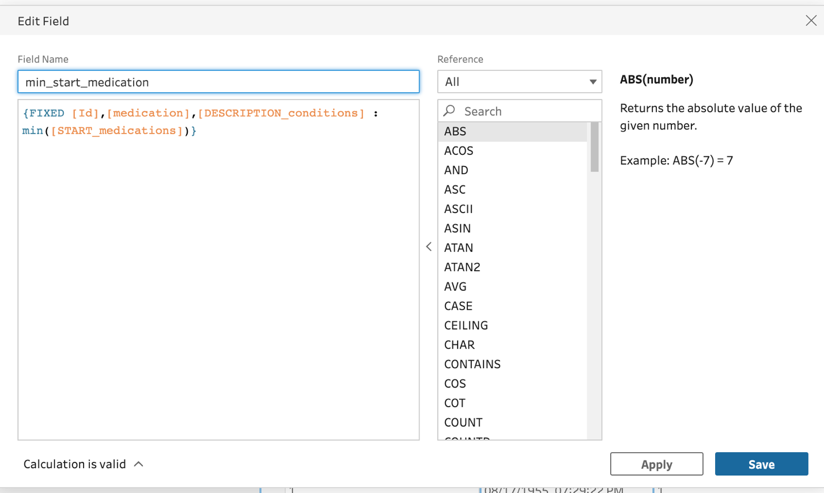

* + Time

The survival time for patient

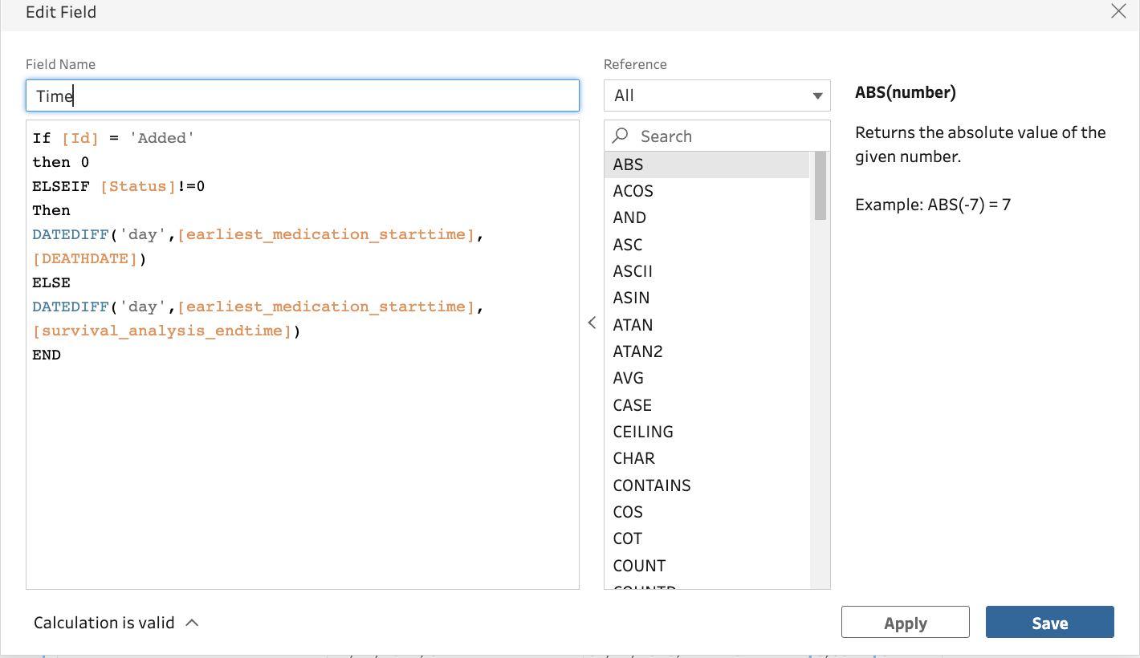

Note:

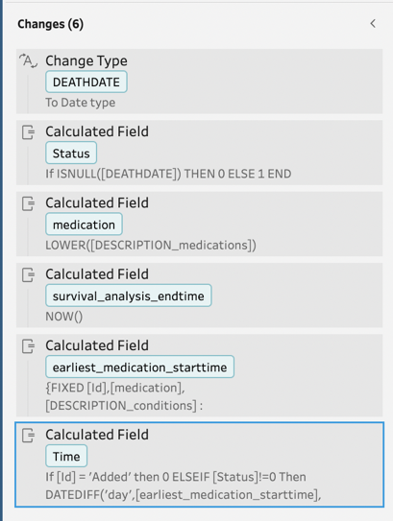

* + - After creating those calculated fields, all the steps will be shown under the Changes, the steps are run in order then need to make sure the calculated field does not use another calculated field created after it.
    - Also need to make sure that the column DEATHDATE is a type of Date, as in the extreme case, all the value in DEATHDATE is null. Move the Change Type step to the beginning of Changes so that the DEATHDATE can be recognized as a Date object
  1. Filter to choose data under specified conditions and medication

Click plus -> Clean Steps: Filter Values…

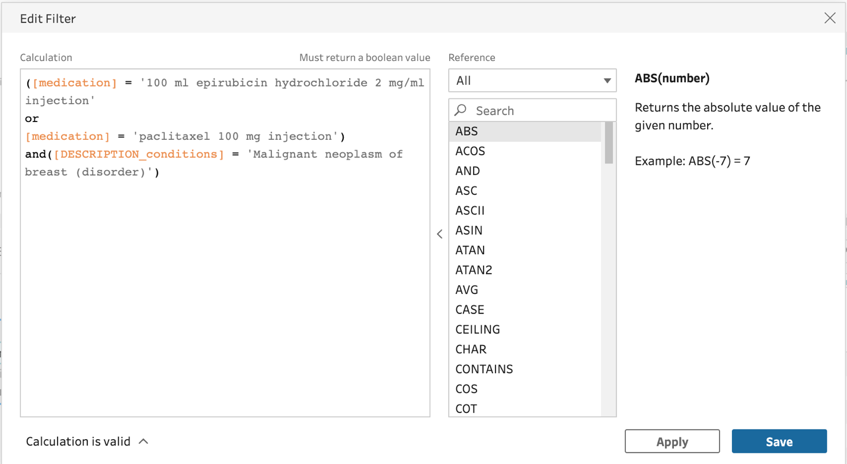

* 1. Filter to get cohort of patients only took exactly one of the drug
  + Number of drug took

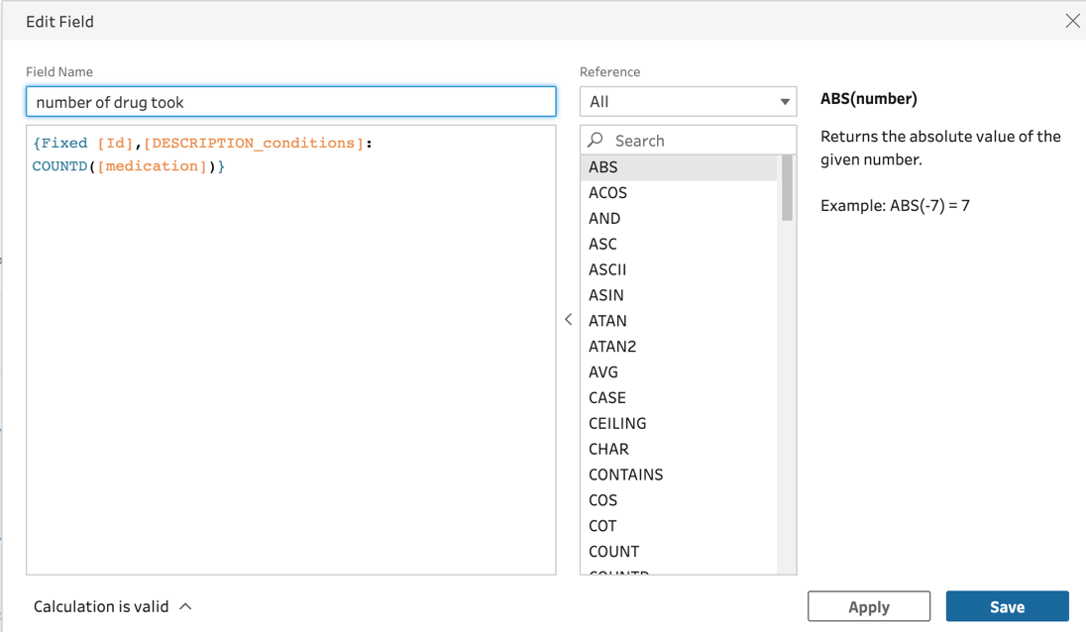

Then filter on the value

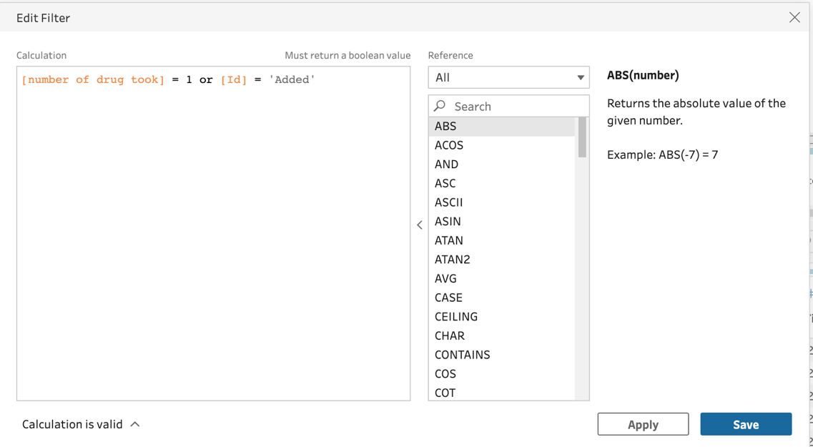

* 1. Filter to data ensure each patient corresponds to one record about the survival time and its status to avoid duplicate counts the patient
  + Patient_row_number

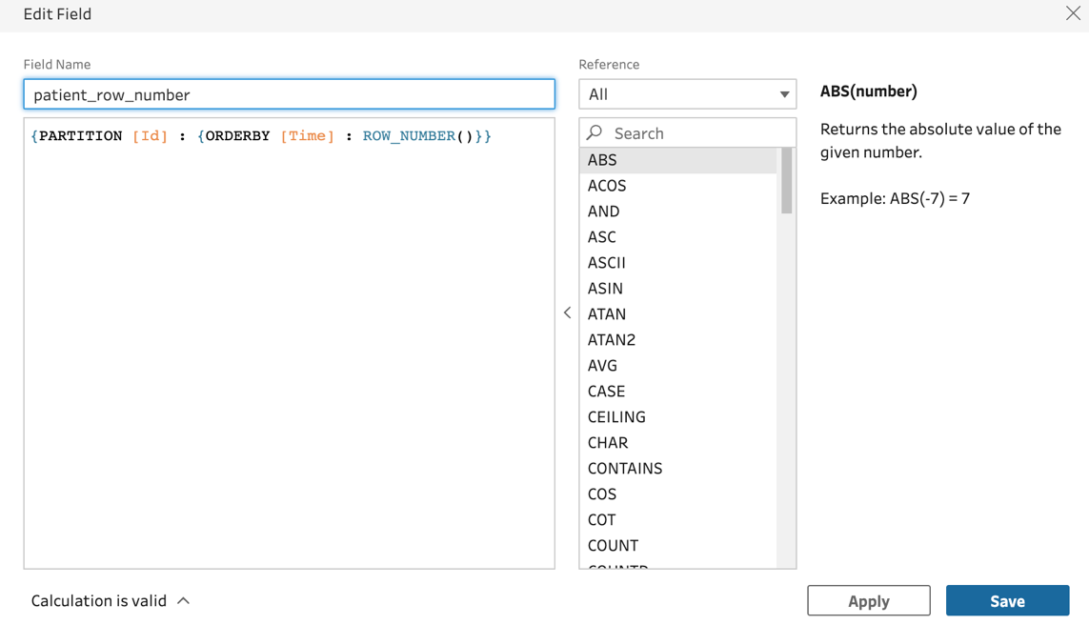

Then filter on

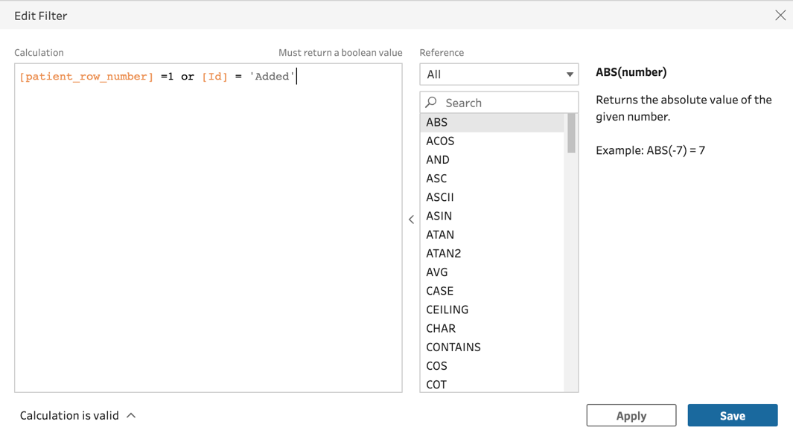

* 1. Output the preprocessed data

Click plus -> Output and click the output(default name as Output.hyper), In mac, the default location that the output stored in /Users/<username>/Documents/My Tableau Prep Repository/Datasources folder

The final flow shown below

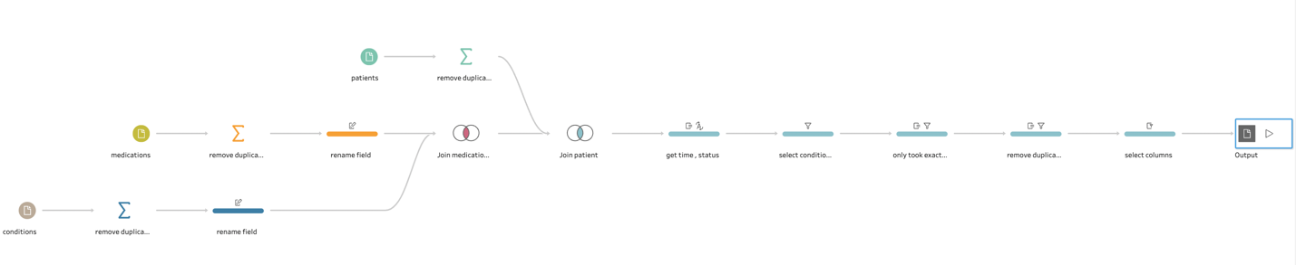

1. Create a new workbook in tableau Desktop

Open a new workbook in tableau from File-> New, then you can get a window shown below

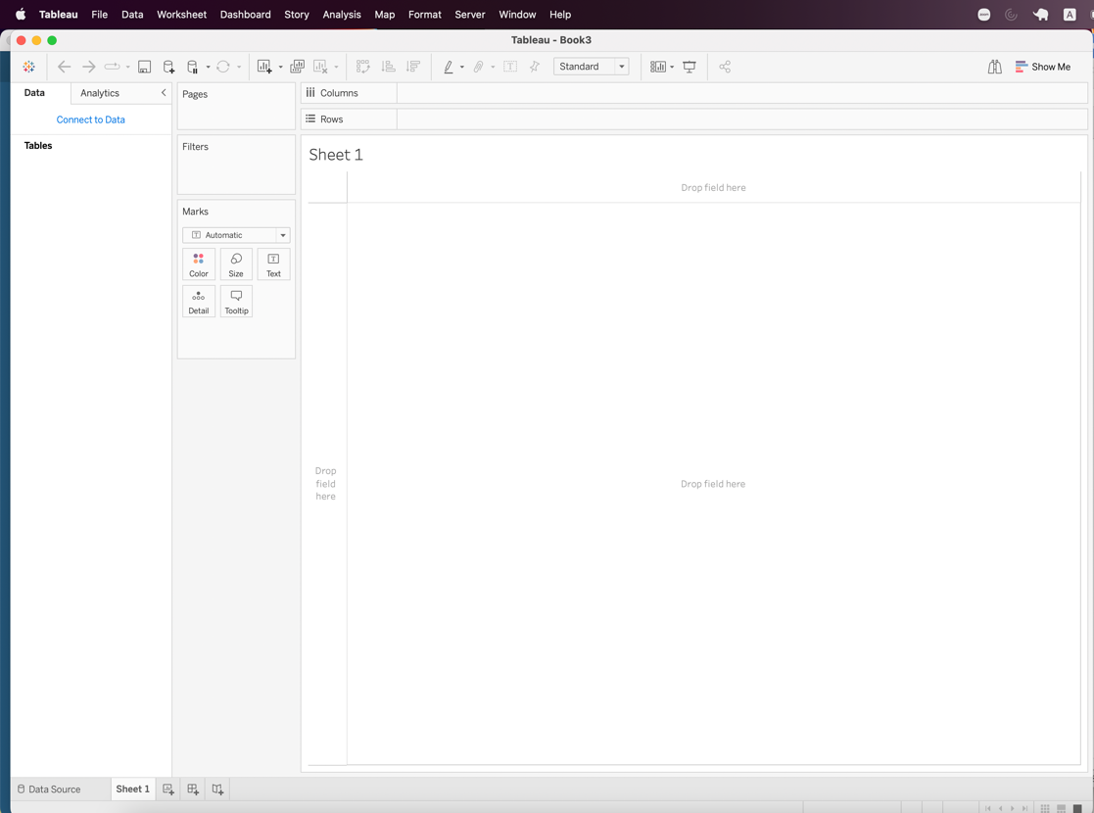

1. Connect data source

Through Data-> New Data Source, Under the To a File choose More… and select the Output. hyper which is the output from the Tableau Prep

1. Generate calculated field in worksheet

In this step, we back to the worksheet page and generate the required field used in Kaplan Meier plots.

Through Analysis -> Create Calculated Field... , we create the below fields

* Number of records

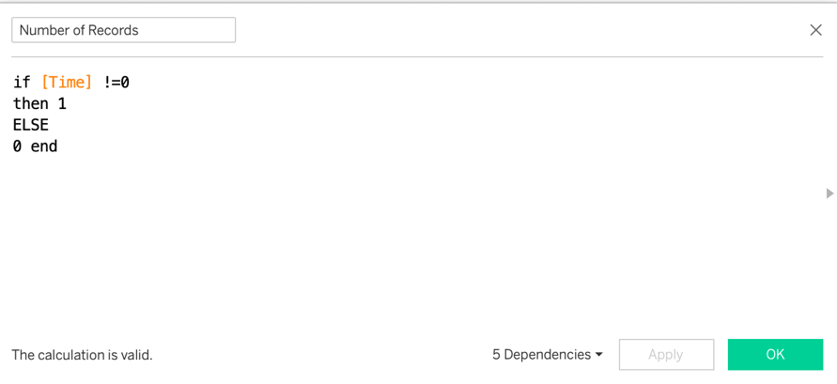

* Survival Probability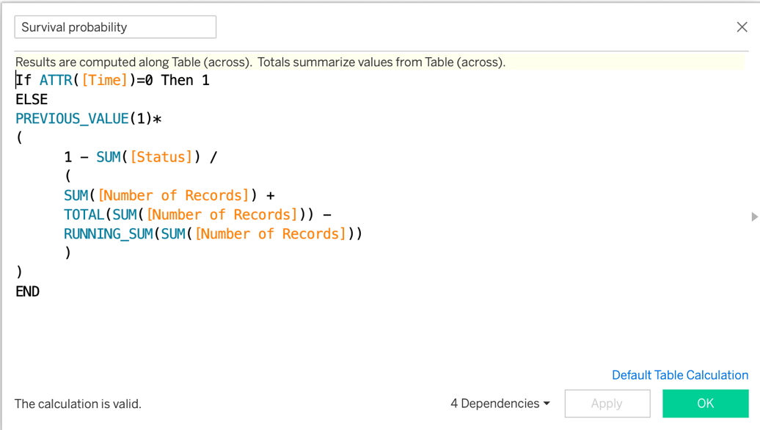
* Refer: <https://www.linkedin.com/pulse/advanced-survival-curves-tableau-part-1-chris-short/>
* Survival Probability dots



* Event happened

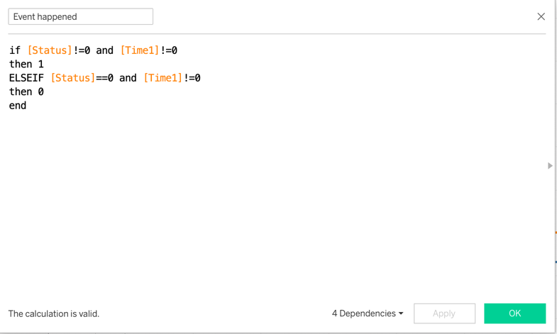

1. Create the plots
   1. Curve plots
   * Drag Time to the Columns and change to dimension
   * Drag Survival probability to Rows
   * Change path to second line type under Marks block
   * Drag medication to color under Marks block



* 1. Annotate point
  + Drag Survival probability dots to Rows
  + Change to dual axis right click on the Survival probability dots in the row

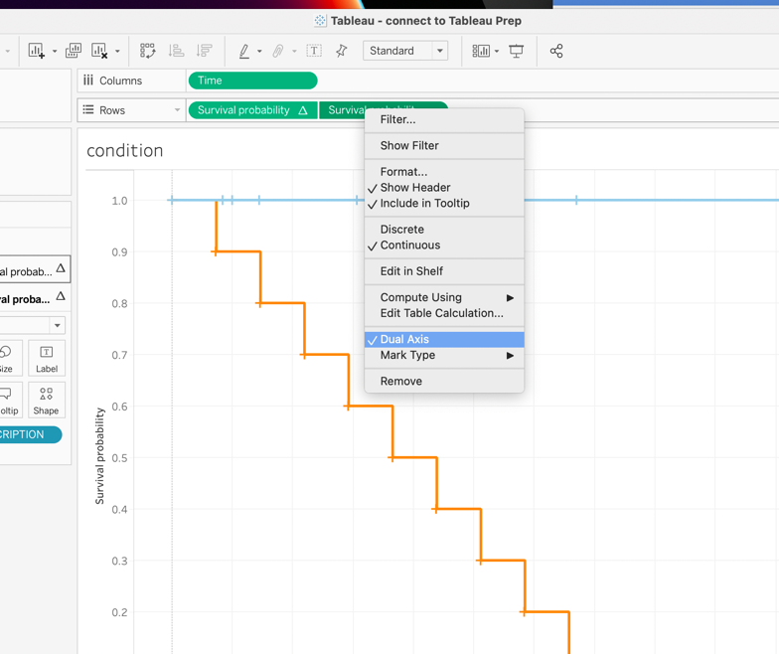

* + Edit axis to Synchronize Axis and hide the axis through untick the Show header

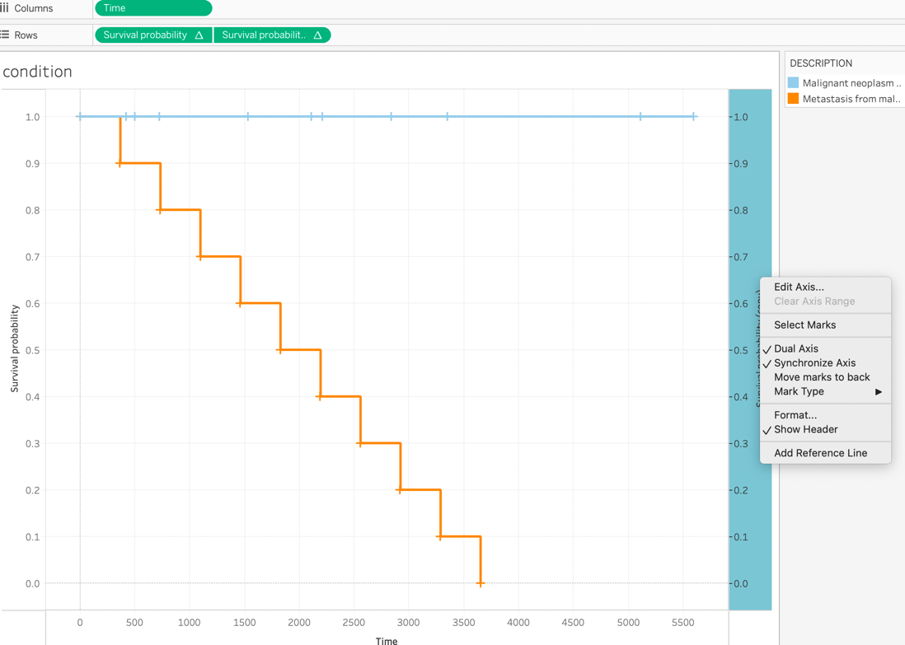

Below is for one condition

Follow similar steps described above, but for this plot only consider patients.csv and conditions.csv, the data join shown below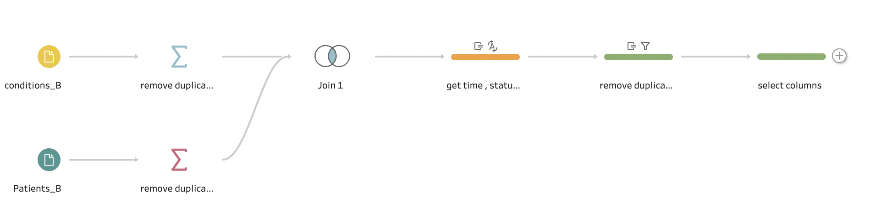

Also not forget to insert the row

* For patients.csv, we add an extra row set Id as ‘Added’ and left other columns empty
* For condition.csv, we add an extra row set Patient as ‘Added’, Description as ‘Malignant neoplasm of breast (disorder)’ which is the analyzed condition, and left column empty

For Kaplan Meier curve compare the survival probability in different conditions (cancer type stored in description in condition table)

Example: Plotting the KM plot analyzing the survival probability in different cancer type with usage of the data in the two_conditions folder

Modify the data

The first step is still to insert few rows into corresponding table so that we do not lose the starting point(survival probability is 1 when time at 0) in KM plot

* For patients.csv, we add an extra row set Id as ‘Added’ and left other columns empty



* For condition.csv, we add two extra rows, for first row set Patient as ‘Added’, Description as ‘Malignant neoplasm of breast (disorder)’, the second row set Patient as ‘Added’, Description as ‘Metastasis from malignant tumor of breast (disorder)’and all the left column as empty



For adding Logrank test it required to integrate R with Tableau

1. Open Rserve

open R then

* + Install Rserve package
    - install.packages("Rserve")
  + Load Rserve package
    - library(Rserve)
  + Enter commands
    - Rserve() -> if there is error said

Fatal error: you must specify '--save', '--no-save' or '--vanilla'

Change to => Rserve(args = "--no-save")

Refer：<https://www.youtube.com/watch?v=g1VhXXOqlRE>

SOCK_ERROR: bind error #48(address already in use)

It means default port 6311 is already in use, then we check what process run on the address and terminate the process.

sudo lsof -i:6311 to get the detail(PID) of the process run on the address

kill -9 <PID>

1. Open tableau
2. Connect R and tableau

Help -> Settings and Performance -> Manage Analytics Extension Connection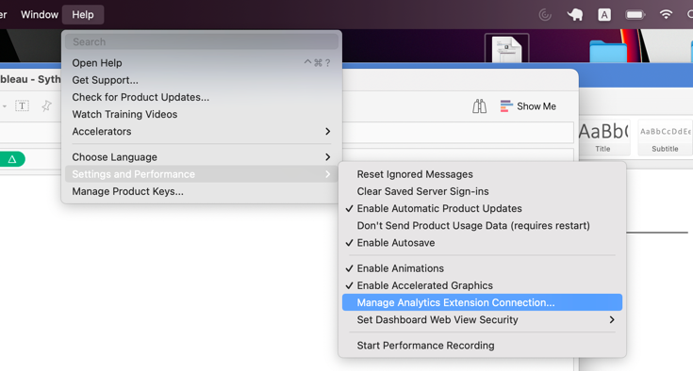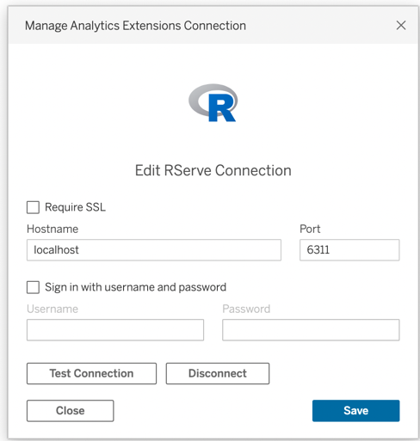

 The default Port for RServe is 6311

After checking the connection is successful, the next step is to create a new workbook and calculated field. To check the connection, simply click the Test connection, if successfully connected, it pops out the window 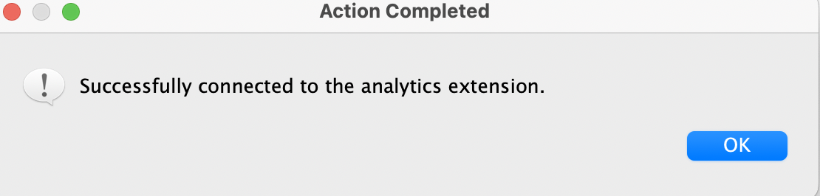

For calculated fields

* Index

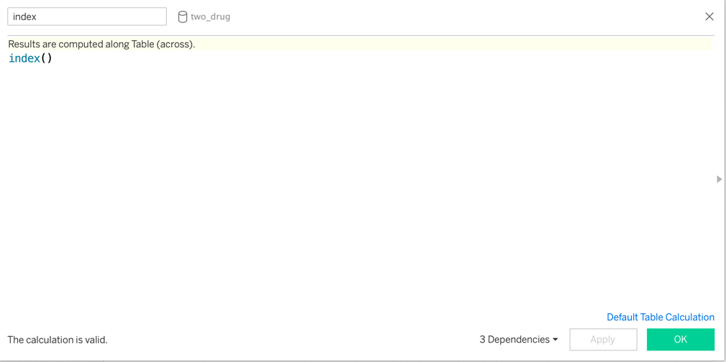

* LogRankTest pvalue
  + for two medication under same condition(cancer type)

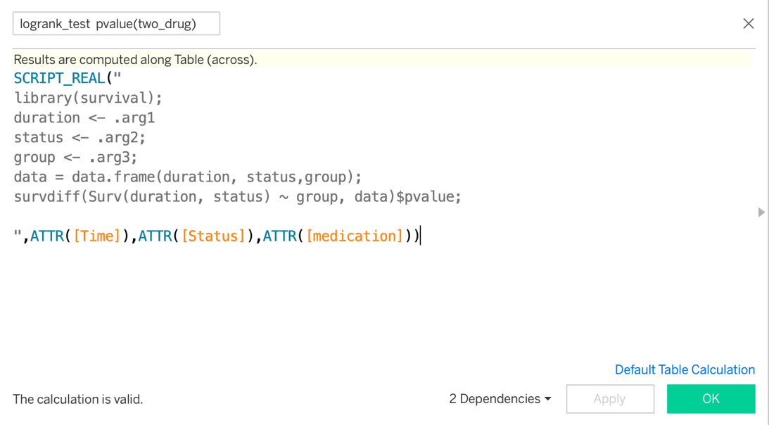

Note: the pvalue from log rank test can also be extracted from the CPH model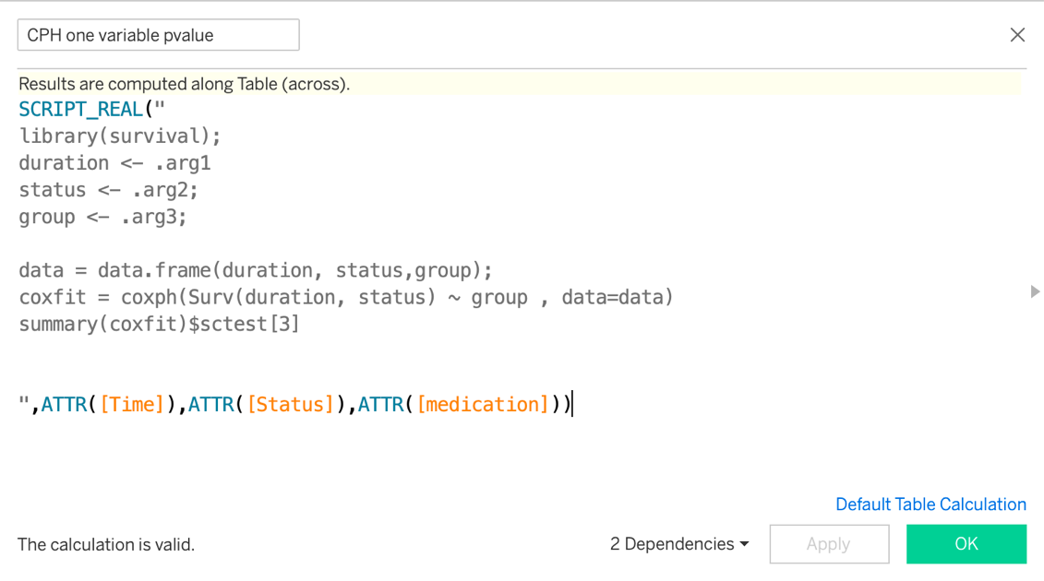

Note:

1. It needs to change the tableau aggregation setting to records level or errors shown below pop out

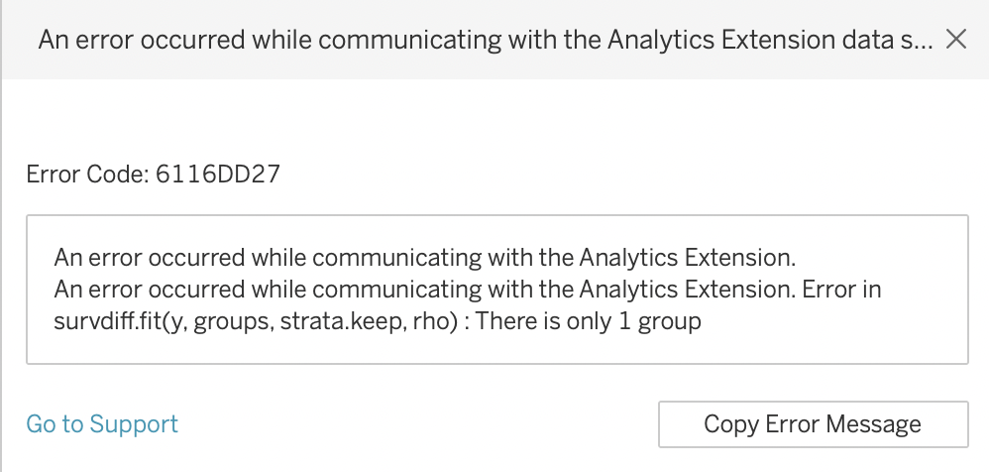

Click Analysis -> Aggregate Measures to ensure Aggregate Measures is NOT selected.

1. Inside logranktest pvalue calculated field

Put Rcode inside SCRIPT_REAL() and this function constrain the return value is real number; .arg1, .arg2, .arg3 corresponding to Time, Status, medication respectively.

The line survdiff(Surv(duration, status) ~ group, data)$pvalue is used to get the pvalue in LogrankTest

1. Since we change the tableau aggregation setting to records level, the p-value are computed for all rows. To only keep only one value, we filter by index and only keep the value at the first position.

For the cox proportional hazard model:

The limitation of the logrank test is it only can be applied on a single categorical variable to test whether it is significantly different if we want to quantify the difference or test on multiple variables(including both categorical variable and continuous variable)

Here we show an example still with two drug cases and add the age when the patient got cancer into consideration

a. Add calculated filed in tableau Prep

* 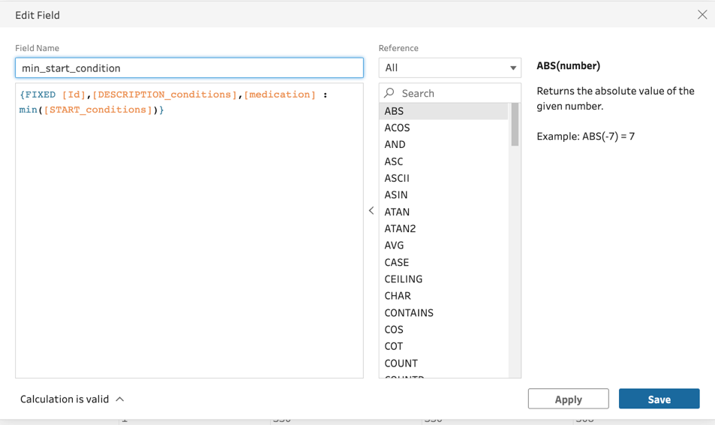
* 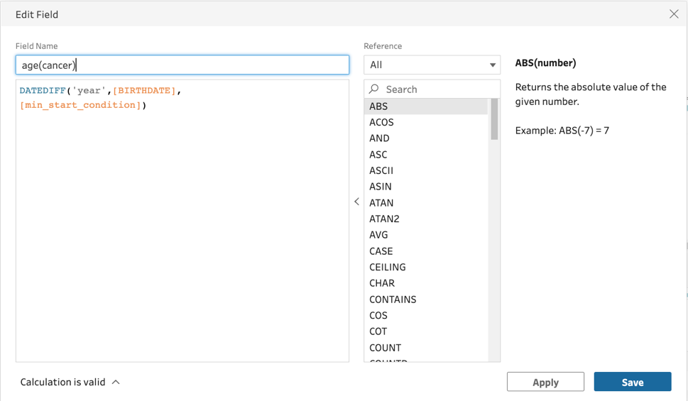

b. Add calculated field in tableau Desktop

- Cox multiple variables

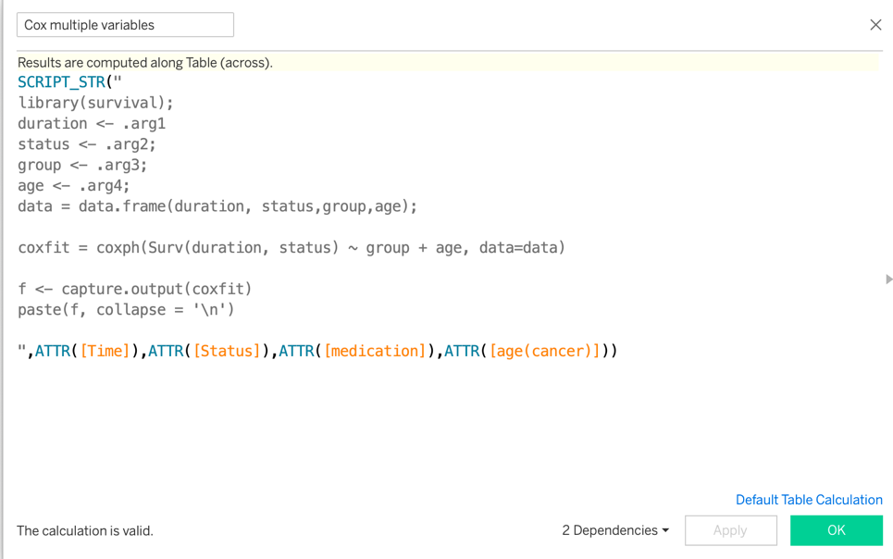

Note: SCRIPT_STR() returns the string output from R, we capture the information from the output from coxfit

1. Build the dashboard

Through Dashboard->New Dashboard; we can create a new dashboard and drag Sheets can add to the dashboard, if want to move the plots, we can click on More option-> floating points then can move freely.

-----check the correctness of Kaplan Meier curve plot in Tableau to the result plotted in R-------

We can check whether the KM curve is correct given the extracted data from Tableau Prep.

Right click on plot -> View data -> choose Full data can store the extracted data to the laptop



Note for the CSV file read in R we need to change the file format to CSV VTF-8(Comma deliminited) (can change by open through excel and changing the format)

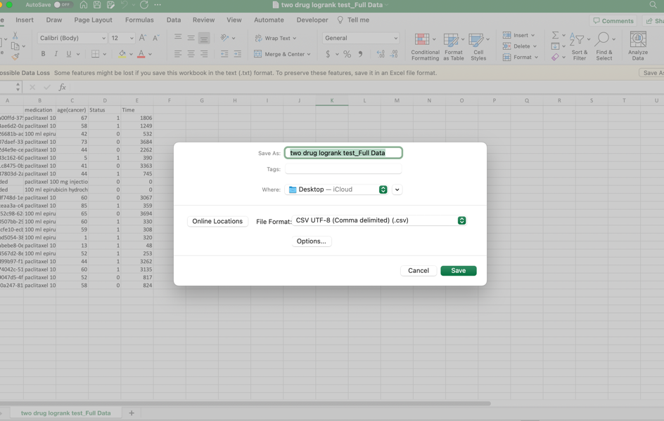

Then use the Kaplan Meier plot function written in R script to check whether the plot is same, detail in the R_kaplan_meier.Rmd file.